Intake Sheet, page 1, Shaded Area
John | 1: Yes | 2: No | 3: Yes | 4: Yes | 5: Yes
George | 1: No | 2: No | 3: Yes | 4: Yes | 5: Yes

Filing Status - Head of Household
Federal Refund - $5,894
State Refund – $2,029

Basic Information
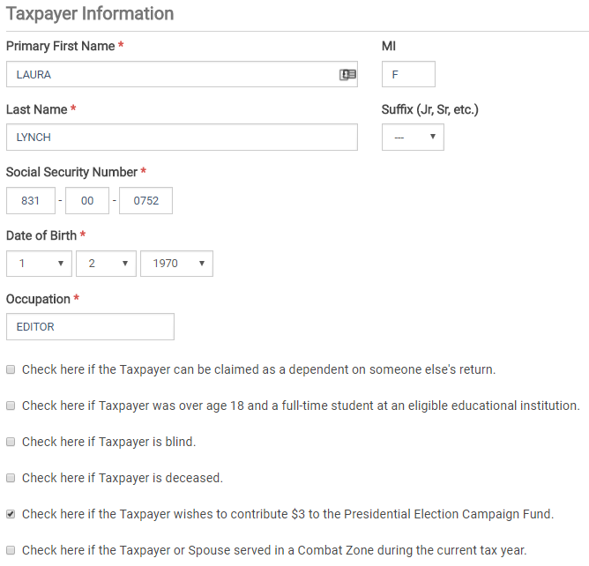
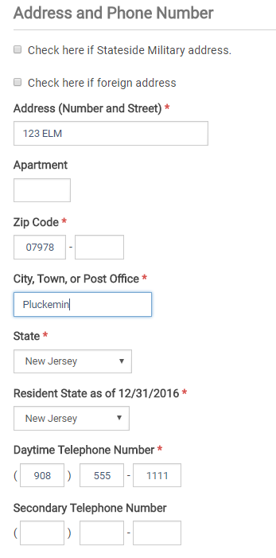
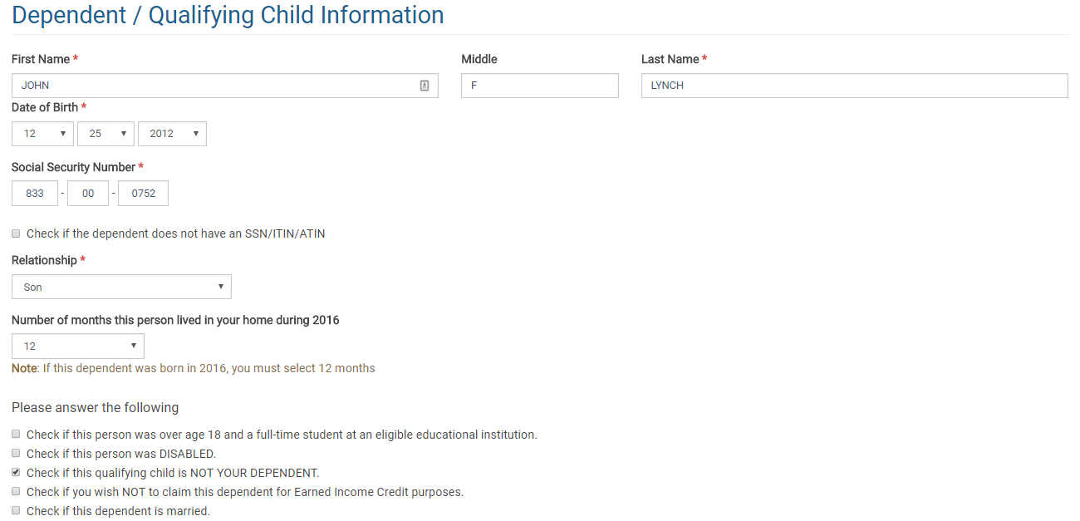
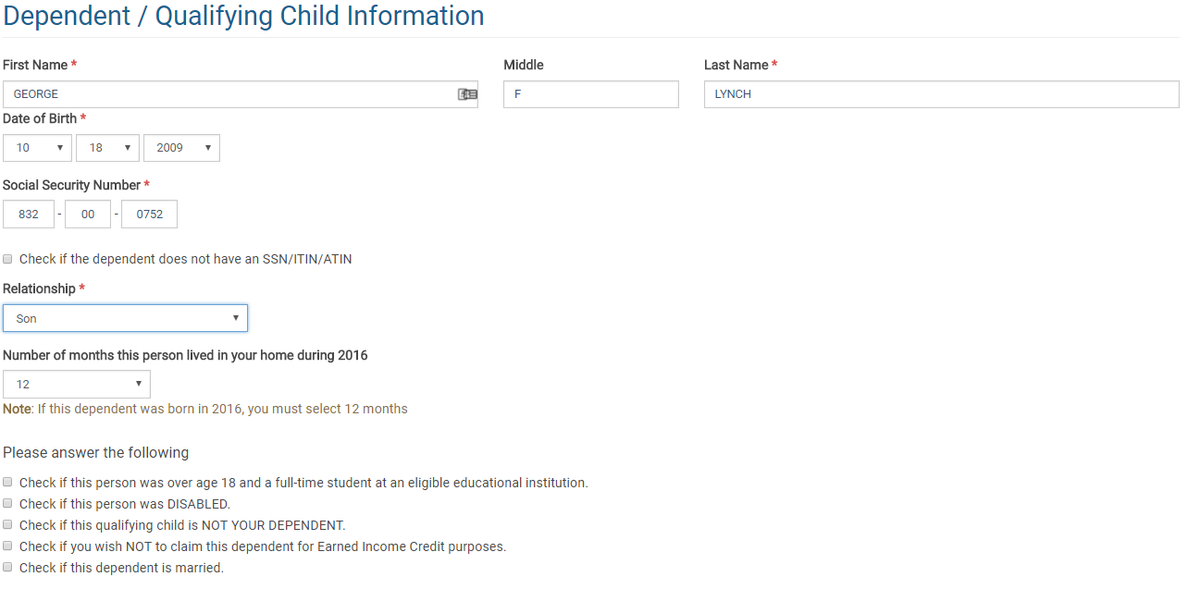
W-2 Wages
ACME Corp
EIN – includes a number
Check employer name and address
ACME CORP
123 MAIN
PLUCKEMIN
NJ
Box 1 = 14,598
Box 2 = 1,002
Box 3 = 14,598
Box 4 = 905
Box 5 = 14,598
Box 6 = 212
Box 12
Code = DD
Amount = 3,000
Box 14
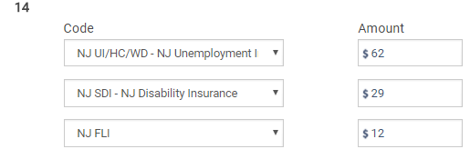

New Jersey Information
State = New Jersey
EIN = a number is in the box
Box 16 = 14,598
Box 17 = 575

ACME Diner
EIN – includes a number
Check employer name and address
ACME DINER
123 MAIN
PLUCKEMIN
NJ
Box 1 = 2,532
Box 2 = 328
Box 3 = 1,944
Box 4 = 157
Box 5 = 2,532
Box 6 = 37
Box 7 = 588
Box 8 = 250
Note: The amount from box 8 automatically goes to Form 4137. You can do a search for the 4137 in
TSO, or view the completed form in the printed return.
Box 14
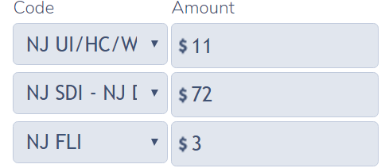

New Jersey Information
State = New Jersey
EIN = a number is in the box
Box 16 = 2,532
Box 17 = 201

Form 4137
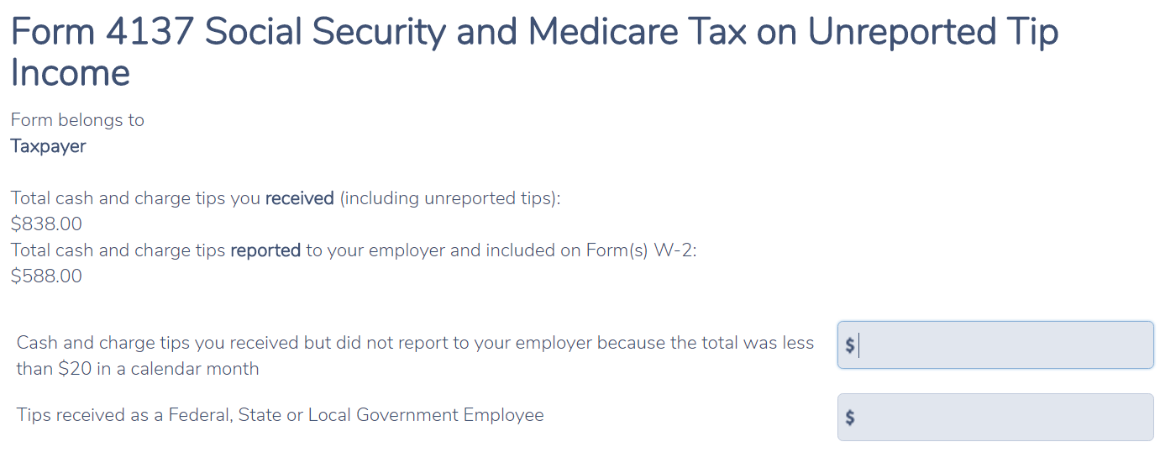

1099-R

ACME IRAS
EIN – includes a number
Check PAYER’S name and address
ACME IRAS
123 MAIN
PLUCKEMIN
NJ
Box 1 = 5,000
Box 2a = 5,000
Box 4 = 750
Box 7 = 1
IRA/SEP/SIMPLE box checked
Form 5329

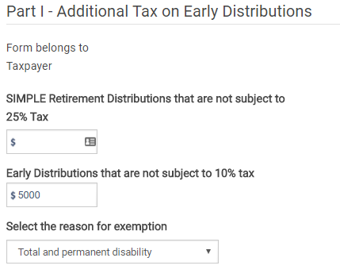

1099-R

ACME Pensions
EIN – includes a number
Check payer’s name and address
ACME PENSIONS
123 MAIN
PLUCKEMIN
NJ
Box 1 = 5,400
Box 2a = 5,400
Box 7 = 3

Check that box on 1099-R checked to move amount to 1040 Line 7

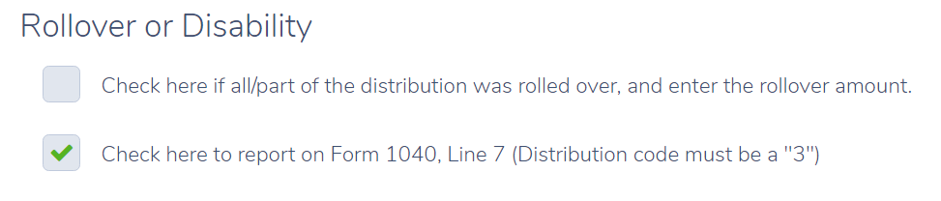

NJ Checklist
Amount of the ACME Pensions Disability Pension should be entered on the NJ Checklist in the Income Subject to Tax Section.
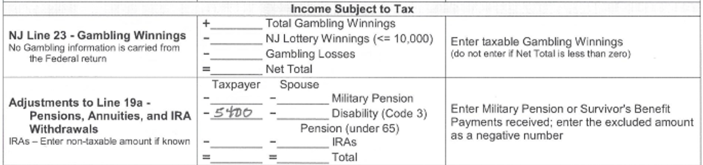

1099-MIsc

ACME Services
EIN – Check a number is entered
Payer
ACME SERVICES
123 ELM
PLUCKEMIN, NJ
Box 7 = 5,000

ACME Partners
EIN – Check a number is entered
Payer
ACME PARTNERS
123 ELM
PLUCKEMIN, NJ
Box 7 = 7,000

Schedule C

Basic Information
Business Code = 561410
Description of Business = Document preparation
All other lines blank

Questions About Business
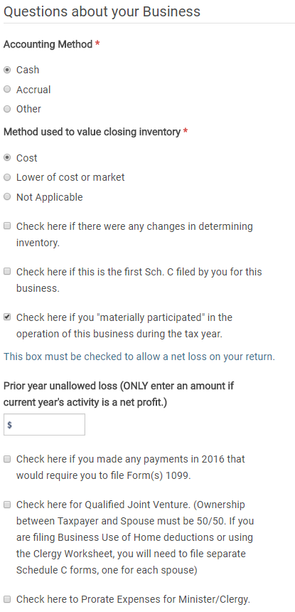

Income
Total amounts from both 1099 MISCs.
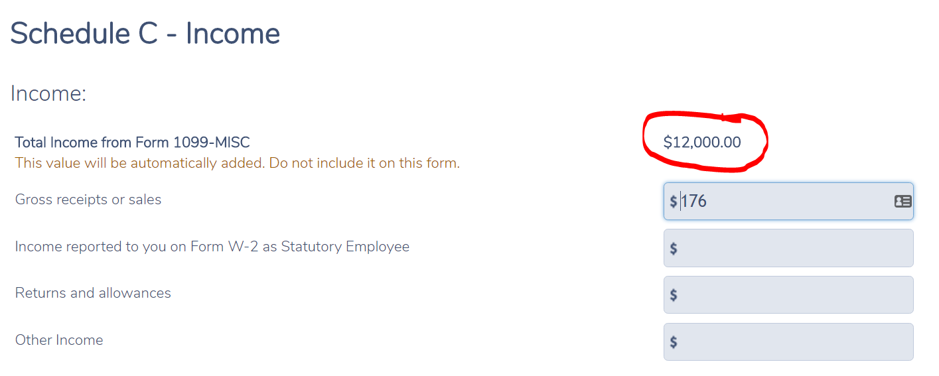

Car & Truck Expenses
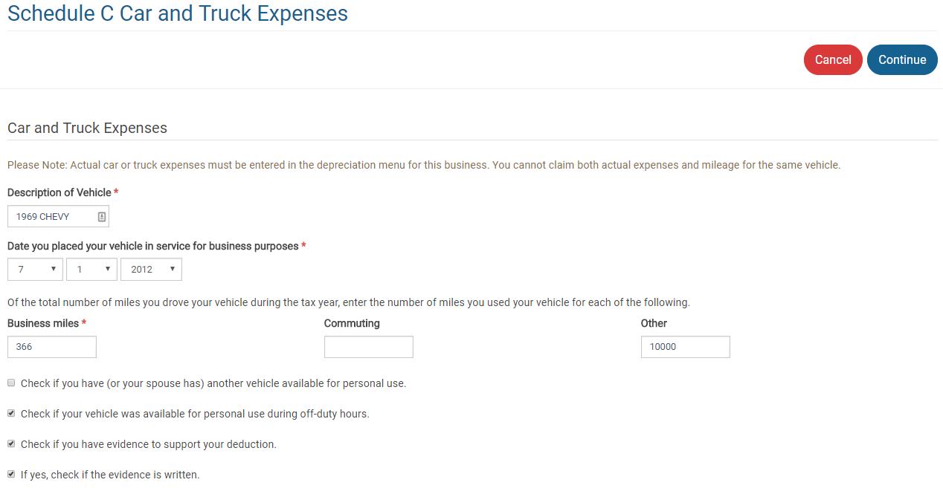

Other Expenses
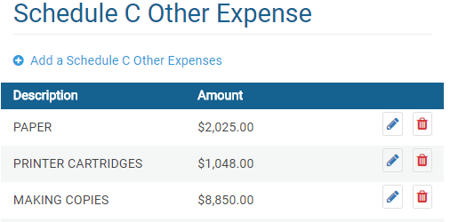

Alimony Received

Schedule A Medical
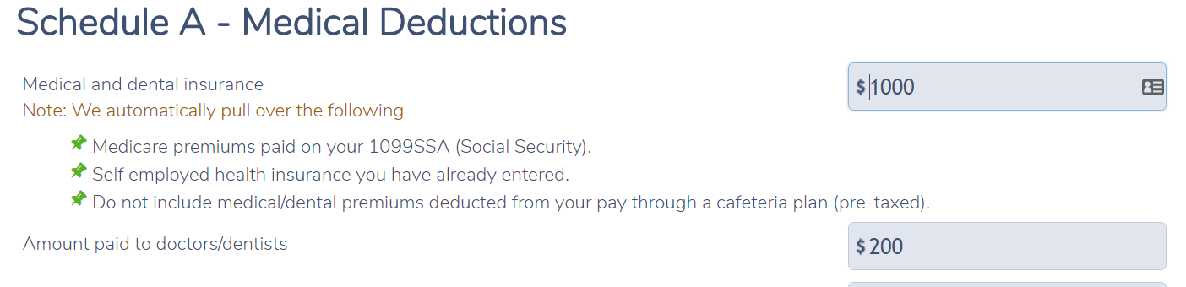
Child Care Credit Form 2441
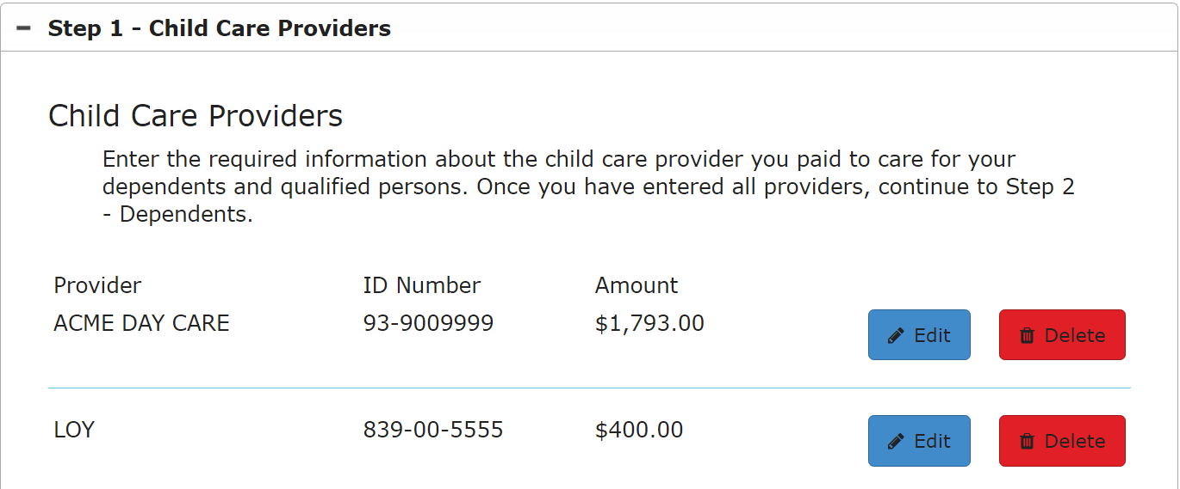

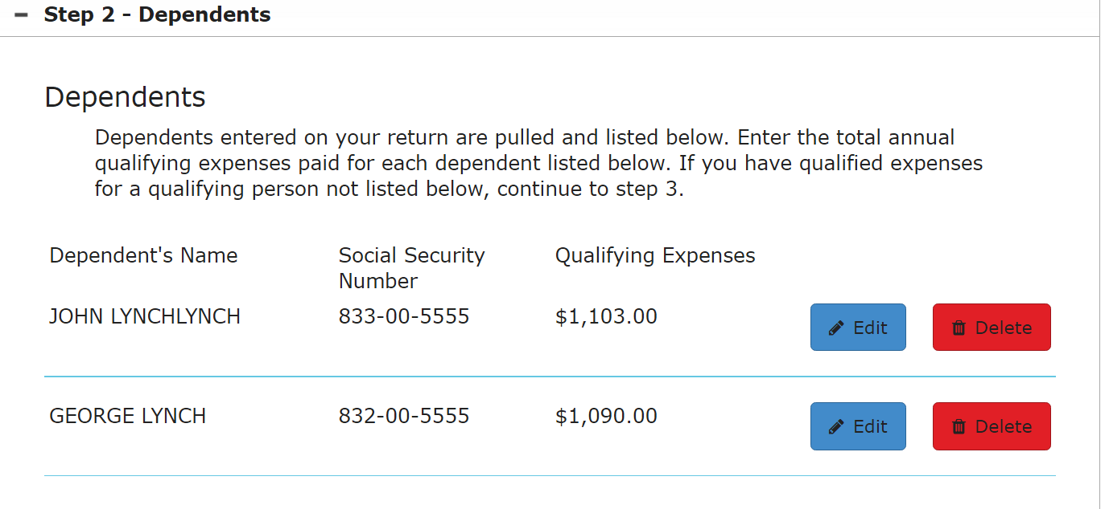

Health Insurance
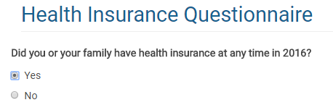

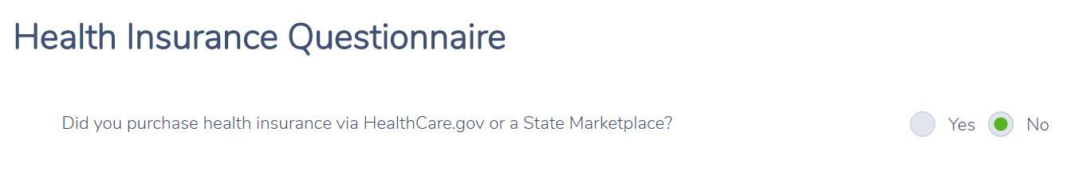
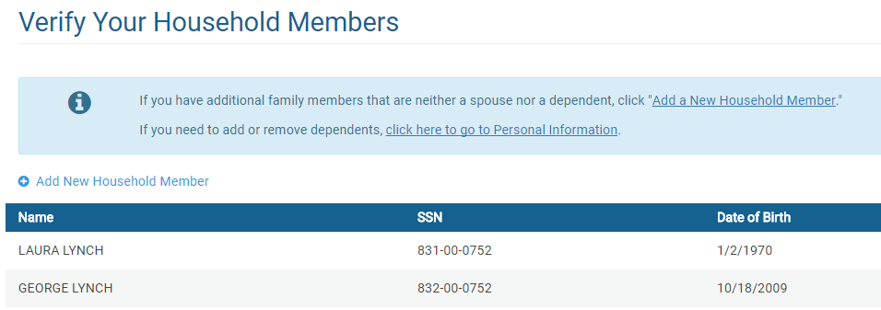
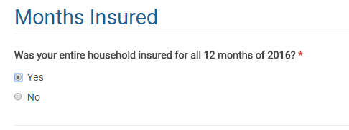

New Jersey Return

Check that the numbers shown in the NJ Checklist below have been properly entered in to TaxSlayer.

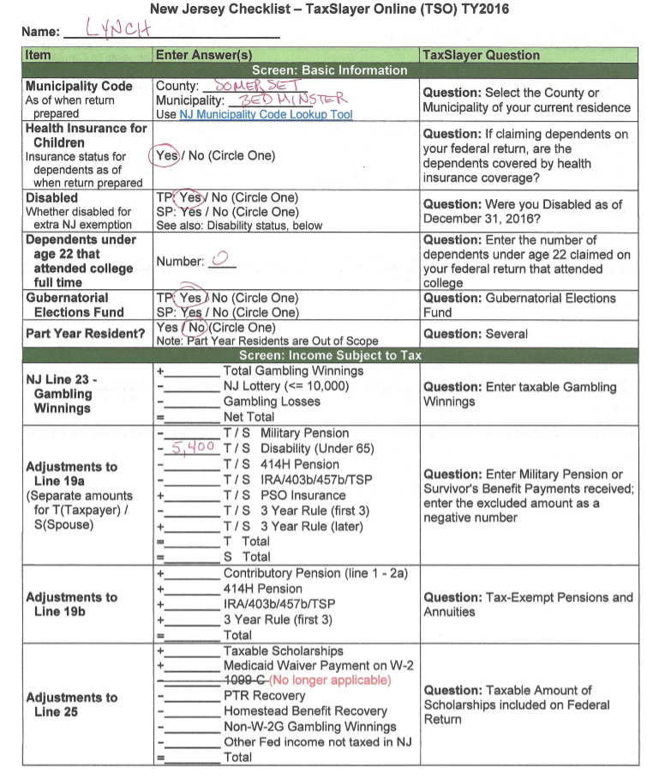

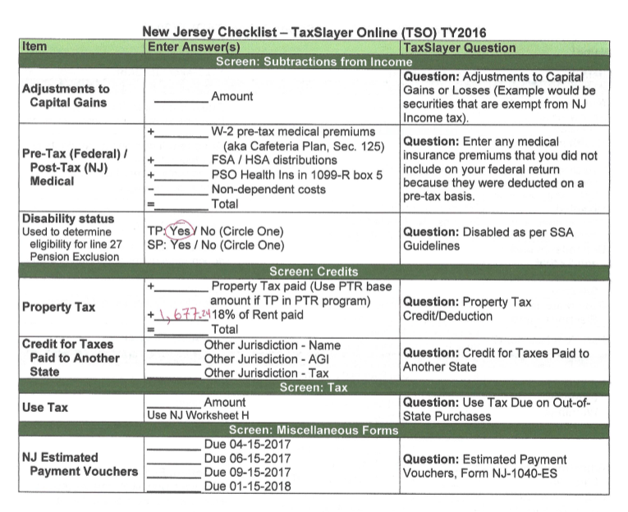

Rent Calculation: [(755*6) + (798*6)] * .18 = 1677

e-fILE
Check that return types are entered as “E-file: Paper Check”
Check that email address is entered on the proper screen
Check that consent placeholder section is completed
Check that questions are answered properly

